Roll No.: 200101044



**Need for Research and Innovations in Highway Consulting**

**By**

**Ashutosh Kumar Dubey**

**200101044**

#### LEA Associates South Asia Pvt. Ltd.

**July, 2021**



**Need for Research and Innovations in Highway Consulting**

**By**

## Ashutosh Kumar Dubey

## 200101044

#### Under the guidance of

Mr. Bidur Kant Jha Prof Gaurav Dilip Tikas

General Manager (Highways) Assistant Professor (Strategy)

LEA Associates South Asia Pvt. Ltd. IMT, Ghaziabad

#### July, 2021

**Abstract**

Highway consultancy is an extremely broad field and highways play a very crucial role in development of a country and play a vital role in the economy of a country. Since the highways are extremely important it becomes very crucial that they keep on improving in quality service and safety standards. For this to play out in the field we must keep on bettering the services offered as per the needs and aspirations of the new age customers always keeping in mind that the technology used in providing the services is of the highest standard possible, therefore we also need to develop technological capabilities and use them to make better highways. For any improvement to happen the first and single most important thing needed is a new and creative way of executing a task and that is what is known as innovation. But innovation by itself is not sufficient, we also need to understand whether the innovation will benefit us or not, whether it will be suitable for a particular area or not, what is it by itself where it can be used when it can be used and how should we make sure that the innovation does not lead to any negative effects. To ensure this we need research. it will not be an understatement to say that” Research capabilities of any firm determine how long it will sustain and what all it will be able to achieve”. If we combine research and innovation and use it to further our capabilities, then satisfactory results will reflect the arduous work that was put in. So, it is an established fact that there is an extreme need for research and innovation in highway consulting. Now to investigate this and to reach a definitive conclusion a target group was selected a which comprised of civil engineers in the age bracket 25 to 30. They were given a detailed questionnaire and their responses illuminated the way forward. A conclusion was reached that funding is the most important aspect of research and innovation and that if we somehow sort our financial troubles then we can easily improve our highways through extensive research and thorough innovation. Various financial models were looked at and it was concluded that multiple models must be used, and some new avenues must be explored to obtain the required amount of funds.

# Certificate of Approval

The following Summer Project Report titled "**Need for Research and Innovations in Highway Consulting**" is hereby approved as a certified study in management carried out and presented in a manner satisfactory to warrant its acceptance as a prerequisite for the award of **Post-Graduate Diploma in Management** for which it has been submitted. It is understood that by this approval the undersigned do not necessarily endorse or approve any statement made, opinion expressed or conclusion drawn therein but approve the Summer Project Report only for the purpose it is submitted.

Prof. Gaurav Dilip Tikas Ashutosh Kumar Dubey

# Certificate from Summer Project Guides

This is to certify that **Mr. Ashutosh Kumar Dubey**, a student of the **Post-Graduate Diploma in Management,** has worked under our guidance and supervision. This Summer Project Report has the requisite standard and to the best of our knowledge no part of it has been reproduced from any other summer project, monograph, report or book.

Prof. Gaurav Dilip Tikas Mr. Bidur Kant Jha

Assistant Professor (Strategy) General Manager (Highways)

IMT, Ghaziabad LEA Associates South Asia Pvt. Ltd.

B-1, E-27, Mathura Rd, Block E, Mohan Cooperative Industrial Estate, Badarpur, New Delhi, Delhi 110044

05/07/2021 05/07/2021

# Table of Contents

Acknowledgement

Abstract

Table of Contents

1. Introduction to the scope of internship & expected deliverables and timelines

Page

2

3

6

7

1.1 Summary of the company and its business……………………………………7

1.2 Business Problem……………………………………………………………...7

1.3 Scope of the project……………………………………………………………7

1.4 Timelines followed during the project………………………………………... 8

1.5 Objective……………………………………………………………………….8

1.6 Project Execution Design: Methodology and Data…………………………….8

1. Literature Review and Industry Analysis…………………………………………………..9

2.0 About Highway Engineering…………………………………………………...9

2.1 Highway Innovation: What has been done……………………………………..9

2.2 Highway Innovation: - What is being done…………………………………….12

2.2.1 Smart traffic lights………………………………………………………12

2.2.2 Pothole detection and sand filling……………………………………….13

2.2.3 Solar panels on roads……………………………………………………13

2.3 Highway Research: What has been done and What is being done……………..13

2.4 Research Hypothesis……………………………………………………………15

3. Data Presentation…………………………………………………………………………..16

3.1 Data Obtained vis-à-vis Questions………………………………………………..16

4. Results & Recommendations………………………………………………………………20

4.1 Findings and conclusions from the research…………………………………...20

4.2 The proposed solution and recommendations………………………………….22

5. Key Learnings, Challenges & Follow-up

5.1 Key learnings from this research……………………………………………….23

5.2 Limitations of this research……………………………………………………..23

5.3 Directions for further research………………………………………………….23

References………………………………………………………………………………24

1. **Introduction to the scope of internship & expected deliverables and timelines**

**1.1 Summary of the company and its business**

LEA Associates South Asia (LASA) Pvt. Ltd.

This infrastructure consulting firm was founded in 1993 with LASA India operating in multiple countries spanning multiple countries in two continents of Asia (Middle East and India) and Africa. After being in the industry for near about three decades now LEA has been able to expand its footprint by recruiting and employing personnel and working on diverse projects across multiple geographies. It is now one of the most preferred infrastructure consultancy service providers in all countries where it operates. LASA India is ISO (International Standardization Organization) certified and is a key stakeholder in infrastructural development projects funded by Asian Development Bank, World Bank, and many other leading multi-stakeholder funding agencies.

**1.2 Business Problem**

Highway Consultancy is a developing field in Civil Engineering. It has been in existence for about a hundred years now. With increasing population and improving technologies in a highly competitive and globalized world it is especially important to stay connected via land transport network. It is essential for a smooth functioning supply chain operations and development of fast, efficient, and effective road network. Highway Consultancy being an advisory firm needs research and innovation to remain useful and relevant. While research will ensure that the activities are being done by the best possible methods within the constraints of budget, time and resources Innovations will ensure that the value creation for effective and efficient execution keeps happening.

**1.3 Scope of the project**

This is a descriptive research topic. Research leads to advancement in the field it is applied to and innovations help in increasing the efficiency and effectiveness of the system. So, this research is being done to know how Research and innovation will help Highway Consultancy, what is to be done, when is the research and innovation best implemented and where all it must be done. It does not deal with any type of exploratory research or Causal research relating to Highway Consulting. That is to say that it is not for Why and How of Highway consulting. It is simply an explanatory research that explains What When and Where of Highway Consulting regarding innovation and Research.

**1.4 Timelines followed during the project**

A lot of research papers and books, journals, newspaper articles were read for the first 20 days (about 3 weeks) after that a target group was selected and contacted, and a questionnaire was prepared this took another 15 days (about 2 weeks). After that the responses were collected and analyzed and by referring various journals articles a recommended solution was reached and the limitations of the study were highlighted. This took around a month. After that drafting and finalizing the report was done in about 20 days (about 3 weeks).

**1.5 Objective**

This research is being done to know how Research and innovation will help Highway Consultancy, what is to be done to further them, when is the research and innovation best implemented and where all it is expectedly feasible.

The research is being conducted to fill gaps in knowledge regarding the need for innovations and research in Highway Consulting. Basically, the frequency and timing of the innovations and research and time, effort, and resource allocation to the same. Also, why, and how research and innovation affect highway consulting positively and why should it be given the importance. It is also an investigation to find out what kind of innovation (out of the four types) would be suitable for the Highway consulting. What part of highway consulting needs innovation, what part needs research and what parts need both?

**1.6 Project Execution Design: Methodology and Data**

Since it is a subjective research topic which is also descriptive in nature the project execution involved a lot of reading from various sources and then distributing a questionnaire among civil engineers in the age bracket 25 to 30. the target group of respondents involving civil engineers were given a set of questions relating to what when and where of highway consulting with regards to Research and innovation they were also asked to allocate a funding mechanism for Research and innovation. These respondents were chosen because they were accessible and because they have knowledge of Civil Engineering and they are young, so they must be having a bent of mind towards research and innovation.

1. **Literature Review and Industry Analysis**

**2.0 About Highway Engineering**

Highway engineering is an engineering discipline branching from civil engineering that involves the Why the need? Because it involves planning, creating design on the basis of plans, construction and related activities while carrying out the plan, taking care of operations on the constructed pathways, looking after the constructed roads and other structures like tunnels etc. which are the primary route of passage for people, goods and services so to ensure an increasingly and ever safe and effective transportation of people and goods continuous research is needed and innovation is a result of applied research that is when a research applied results in a better or newer form of all the functions and processes involved in highway engineering.

Standards of highway engineering are continuously being improved. Highway engineers have to take into consideration a lot of factors some of which are : future traffic measures that is how many vehicles of what type will be plying on road that is to be constructed, Also how to design the crossways is a very crucial decision to be made because crossways are major points where collision of vehicles and other accidents inevitably happen what should be the geometry of the road elements at what angles and lengths and width and height will they be located and the considerations of design aspects, also what all materials can be used to construct the pavement ,the dimensions, the design and orientation of the pavement is also very crucial, also to know if we could construct a pavement which can be maintained with minimal effort and at minimum expense.

**2.1 Highway Innovation: What has been done**

Highway innovation is aimed at reduction in greenhouse gas emissions and to create infrastructure with higher safety standards and higher life period of the creation. Highway consulting firms keep themselves updated with the best-in-class technological abilities so that they can provide best services. Also, they are inclined towards finding multiple innovative solutions so that they can provide us with more comforting lifestyle and try to fulfill a client's highest aspirations at lowest costs incurred.

Currently at the time of Covid they are working and providing Telemedicine solution services to help us fight and contain the disease and build a healthier environment.

Innovation is one of the fundamental objectives of the Highway/Infrastructure Consulting firms. So, it is only natural that they keep themselves abreast of all the latest new developments in technology and operations regarding their field that is infrastructure. Development of any tech for example: technological enhancements like FasTag to collect tolls at checkpoints, application and results for any newly developed financial tool that can help in smooth structuring of financial resources etc.

As has been the case during the last half decade Infrastructure consulting firms (ICFs) have invested billions of dollars to investigate and implement various aspects of research and innovation for infrastructure development. The firms have been able to innovate in every phase of the taken-up projects and they have been able to capitalize on it and develop capabilities that they never possessed before e.g.: -differentiated and dynamic pricing strategies, applications for mobile phones with improved interaction interface and enhanced user experience, funding mechanism for projects has also undergone a shift due to changing methods.

Lanes managed by Infrastructure consulting firms have sought to decrease traffic movement and they have been able to do that on urban road networks whilst improving their serviceability. This was done by optimizing and adjusting different lanes by adding new toll lanes so that decongestion could happen. For pricing, the new lanes newer toll technologies are used.

Dynamic and differentiated pricing systems are also used by lanes in USA, where in recent past they used calculations involving multiple variables of safety, environmental conditions, whether it is a working day or not and traffic considerations which has led to a reduction of about 17% in road accidents and a 26% increment in revenues generated.

Even ICFs have been able to develop a new tool called Toll Flow Tool (developed by Ferrovial) so that they can manage queues. It also does traffic predictions and gives details of anticipated traffic which makes traffic flow smoother thereby improving the quality of service given to the users.

Also, the ICFs have been able to develop another tool which uses Fingerprinting to improve license reading of vehicles which is done by using algorithm for image identification. The algorithmic system analyses image of vehicle's rear part and can identify most important characteristics of the vehicle, thus making identification of a vehicle irrespective of its location once it is captured by the system.

In the ushering Era of Digital Transformation of businesses and increased usage of online platforms have made mobile applications quite an indispensable part of any firm. Same is the case with ICFs and they are using it everywhere from making payments to mobile applications that enable user to reduce their time of travel have been quite useful and have been able to decongest traffic on highways.

An app called Satelise has been developed by ICFs which allows the user to make toll payments directly using smartphone thus eliminating the use of any device attached to the vehicle. The app works by using Remote sensing using the satellite position of the vehicle. Another app called Drive on Texpress has been developed. This one is used to manage lanes in Texas of USA. The app selects vehicles that carry more than two passengers and rewards them with 50% discount when the traffic flow is heavy. So, in a way it is likely that the use of shared vehicles will increase.

Ferrovial, a highway consultancy firm has developed a platform called "Paytolls" on web in its Portugal unit that helps foreign nationality vehicle passengers pay for toll facilities. The web platform has eased the toll payment for foreign vehicles on two highways of Portugal.

Infrastructure consulting firms have also made inroads in the field of advanced data analysis using tools of machine learning and artificial intelligence by using big data they have been able to interpret the behavior of passengers and road traffic and as a result of all this they can now use predictive modeling to predict road traffic and also estimate the number of passengers thus enabling us to know what ours will be rush hours and hence we can prepare in advance to handle a huge traffic also since machine learning is involved the machines can learn the behavior of the traffic and a much reliable prediction can be made with regards to the traffic.

A huge amount of data is generated when we study the user behavior of passengers plying on roads. This data can provide extremely useful insights and extremely valuable knowledge which can help us to generate more revenue and improve our services further.

Infrastructure consulting firms have also innovated the ways of financing their projects they are now able to gather finances for a project of any scale owing to the trust that they have built over the years they have been able to collaborate with multiple partners and stakeholders and have been able to finance their projects much faster. Many firms have created multiple opportunities for funding and have received many awards for producing great ideas to secure finances.

Infrastructure consulting firms have also made inroads in the field of advanced data analysis using tools of machine learning and artificial intelligence by using big data they have been able to interpret the behavior of passengers and road traffic and as a result of all this they can now use predictive modeling to predict road traffic and also estimate the number of passengers thus enabling us to know what ours will be rush hours and hence we can prepare in advance to handle a huge traffic also since machine learning is involved the machines can learn the behavior of the traffic and a much reliable prediction can be made with regards to the traffic.

A huge amount of data is generated when we study the user behavior of passengers plying on roads. This data can provide especially useful insights and extremely valuable knowledge which can help us to generate more revenue and improve our services further.

Infrastructure consulting firms have also innovated the ways of financing their projects they are now able to gather finances for a project of any scale owing to the trust that they have built over the years they have been able to collaborate with multiple partners and stakeholders and have been able to finance their projects much faster. Many firms have created multiple opportunities for funding and have received many awards for producing great ideas to secure finances.

**2.2 Highway Innovation: - What is being done**.

**2.2.1 Smart traffic lights**

An innovation that is taking place now is the traffic lights that communicate with each other and pass on information to each other about the speed of the vehicles and their trajectories this happens in real time therefore allowing the traffic lights to adjust and allow vehicles in such a manner to minimize the traffic. These adaptable traffic lights have made the movement of traffic Extremely efficient.

**2.2.2 Pothole detection and sand filling**

On iced roads, the trucks carrying sands and salt were used to treat the roads that were damaged because of the snowfall. One of the great shortcomings after way of treating the roads was that each part of the road had to be treated equally there by using much more resources than needed. To get rid of this problem we now have a system which uses radar and detects damaged parts of the road and classifies and figures out weather it needs salt or sand or water for effectively repairing the damage. The only thing then left for the trucks to do is reaching that place and giving it the treatment, it needs thus making the task much easier.

Not only this but the radar also provides information with regards to any new pothole farming on the road. So, if you have a radar installed then you know that where is the bottle getting formed and what is the kind of treatment that it needs thus making the whole task of bottle detection and its filling how much less cumbrous task.

**2.2.3 Solar panels on roads**

For tapping the solar energy various methods have been used. Until now we have seen rooftop solar panels and installed solar panels on desert like lands but this is the first time that we are seeing solar panels installed on roads. This is being practiced in Netherlands, where the road surface area is more than that of the rooftop area. And they have been able to do it successfully. Up till now it has been implemented on low traffic roads and about 10,000 kilowatt hours of power has been generated using these panels. This energy is being used to light up the street lights and traffic lights. Not only that it is also being used to melt the ice on the roads in the times of snowfall that is working as a multi-purpose energy source.

**2.3 Highway Research: What has been done and What is being done**

There are three key areas where research activities happen. The first one is Management of highways the second one is sustainable transportation and the third one it was safety and related measures.

Researches nowadays consider not only the material aspect but they also try to do a behavioral analysis. For this purpose, they use other subjects of social science and psychology to try and get a better view off the problem that they are trying to solve. Research is usually an activity that is collaborated and there are multiple stakeholders involved. As far as highway research is concerned many leading organizations of the world right from World Bank for finance to national research councils and road development organizations all around the world all of these collaborate and try to produce an excellent research work. involvement of multiple stakeholders also makes this process much smoother and we also have much more creative ideas and our diverse viewpoint with regards to what is to be done. Transport sustainability deals with the impact of medium and large-scale changes in design and structure and involves the time factor considering what will happen in short term and what will happen in long term

Now coming to the topics on which research is being done or has been done in the recent past. There has been research to study the economics off road making and management, payment design is one of the most researched areas. Then there have been researchers which have collected data about traffic conditions, there has also been research to study the effects of greenhouse gas emissions and safety studies to manage any unwanted circumstances like a disaster. there have also been studies aimed at managing the energy. Through the data collected there have been predictive modeling studies to facilitate traffic movements. Also there have been at least that try to understand walking and cycling as a part of traffic thereby covering everyone on the road. various tools have been developed to manage the lifecycle costs and to ensure a higher safety standard.

Some of the examples of research projects undertaken are:

1. There was a study done in UK aimed at designing the transportation system to meet the needs of the elderly.
2. Then there was a study done in France this study aimed to find a rating system that could assign ratings to roads thereby helping the passengers choose the perfect road to travel on.
3. Another study done by a group of researchers aimed to find the perfect material for constructing the road pavement which remains unaffected by climate or weather conditions.
4. Lastly there have been studies to find safety and sustainability standards of urban roads in poor and middle-income countries so that their sufferings could be alleviated.

**2.4 Research Hypotheses**

Hypothesis 1: Need of research is not related to the timing.

Hypothesis2: Need of Innovation is not related to the timing.

Hypothesis 3: Perception of consumers regarding research and innovation cannot be captured in terms of years.

Hypothesis 4: Timing of an innovation launch cannot be fixed.

Hypothesis 5: Type of innovation that is to be used for highway consultancy cannot be found.

Hypothesis 6: Area of highway consultancy versus the need for research cannot be rated on a Likert scale.

Hypothesis 7: Area of highway consultancy versus the need for innovation cannot be rated on a Likert scale.

Hypothesis 8: Research and innovation are not related to each other.

Hypothesis 9: Earned income is the best strategic option for financing research and innovations.

Hypothesis 10: It cannot be decided whether to allocate the time and resources to research or to innovation.

**3. Data Presentation**

**3.1 Data Obtained vis-à-vis Questions**

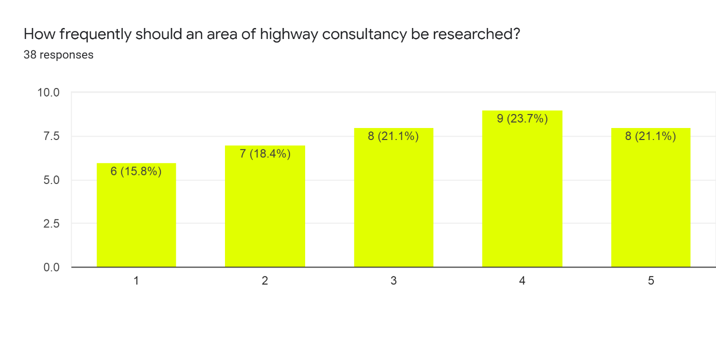

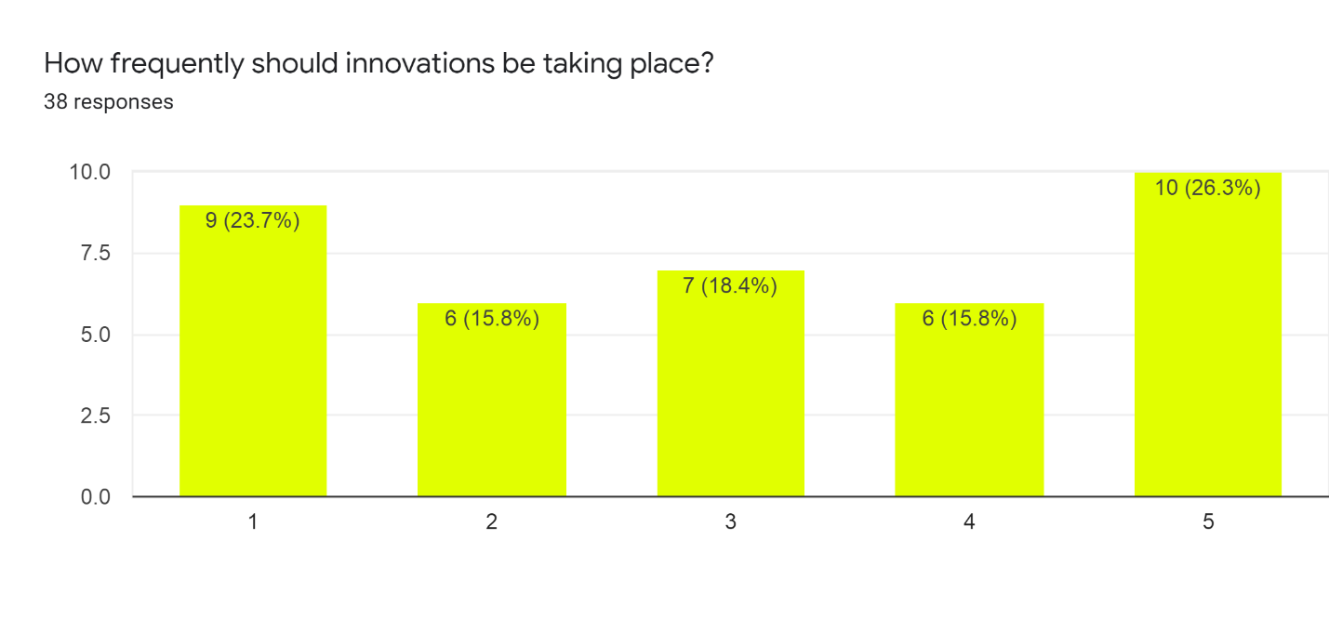

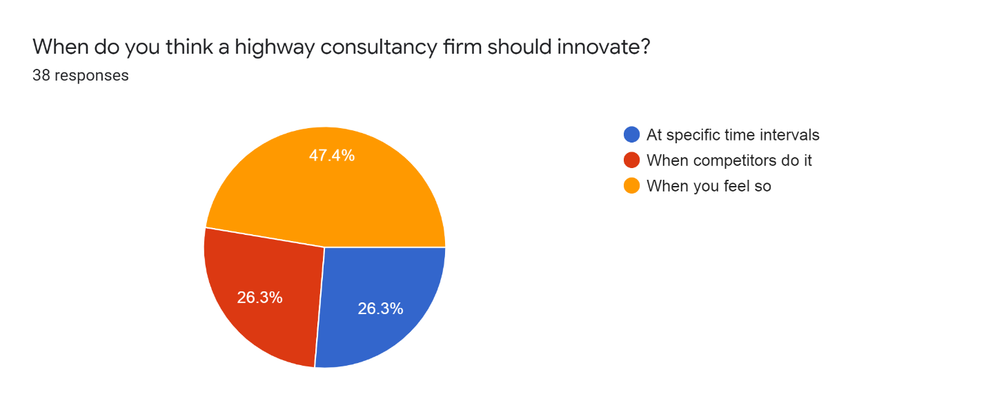

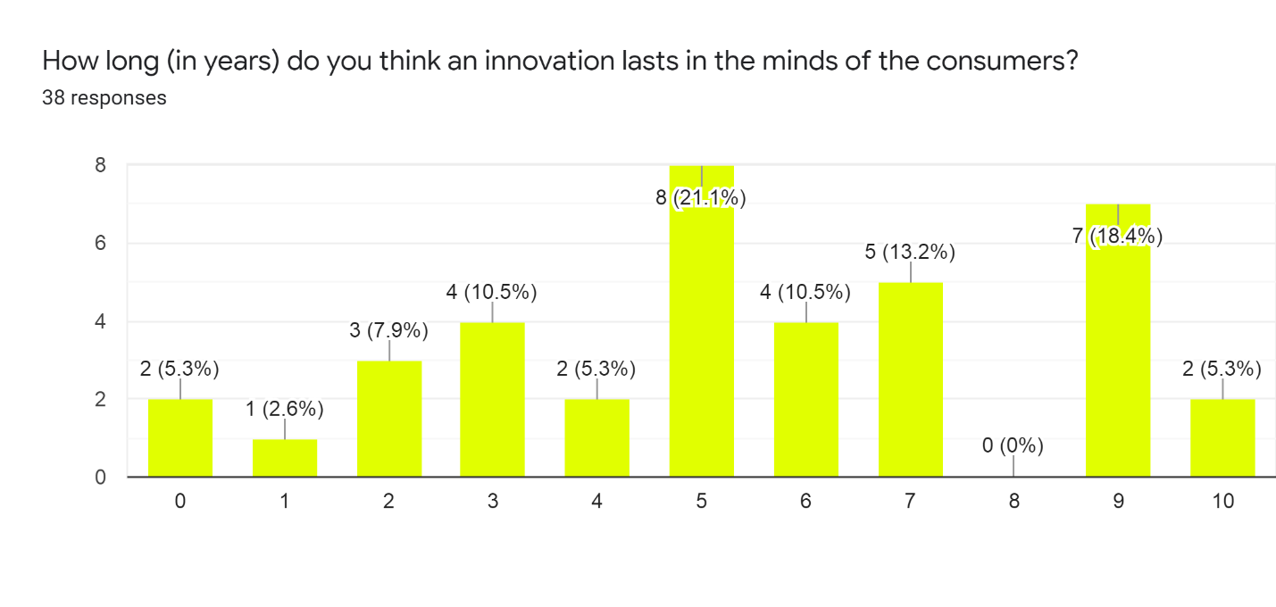

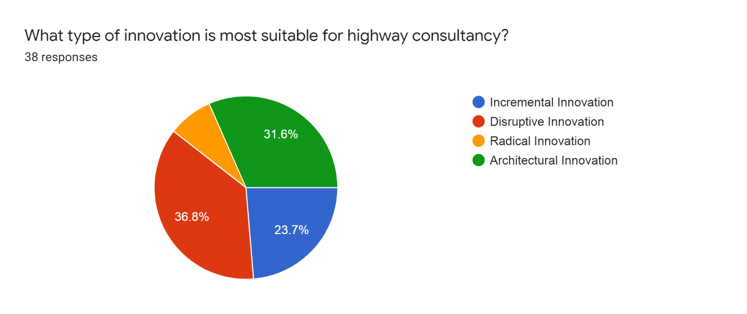

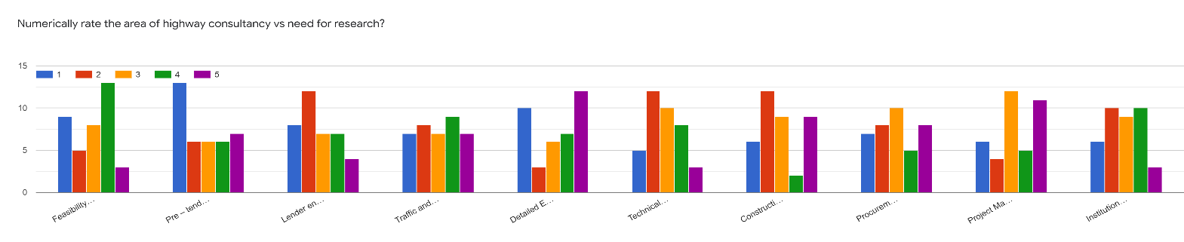

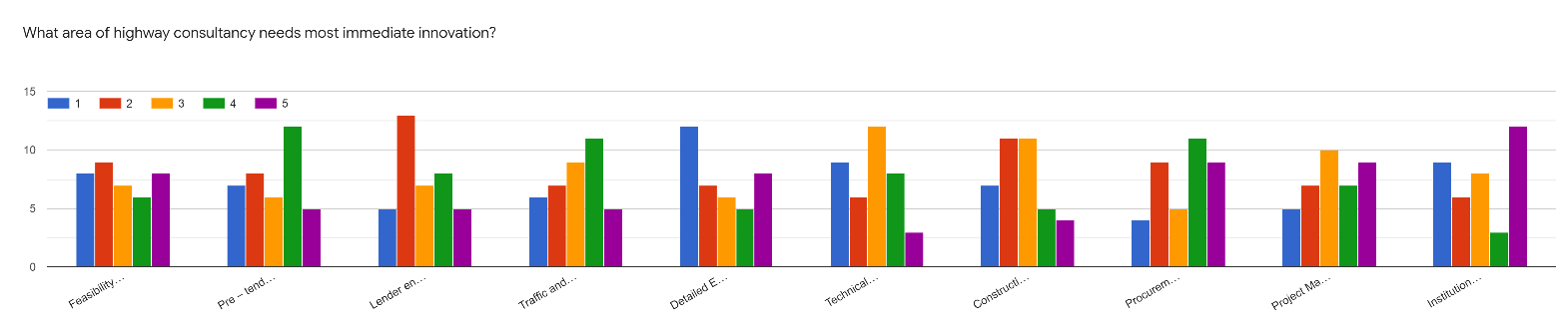

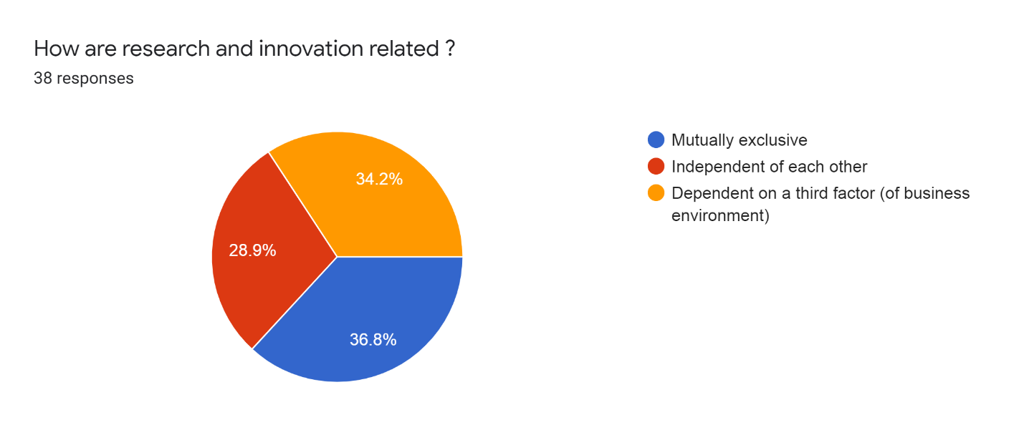

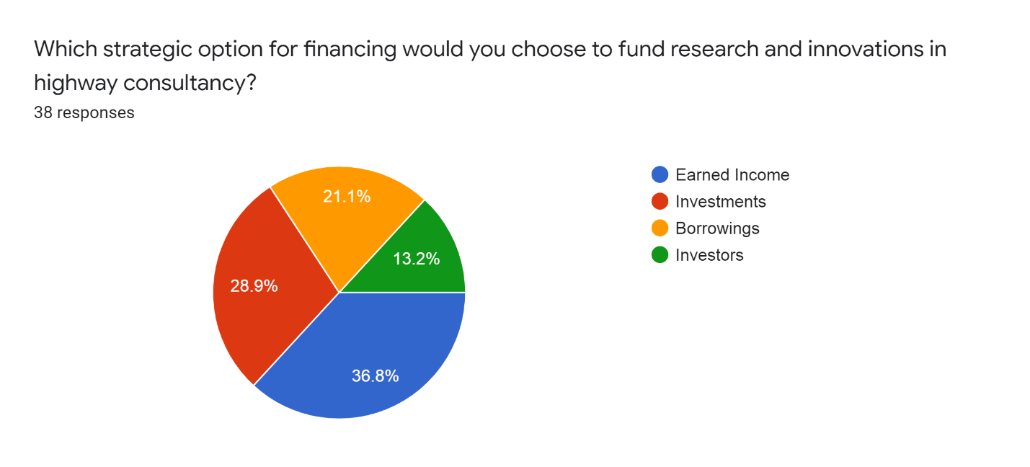

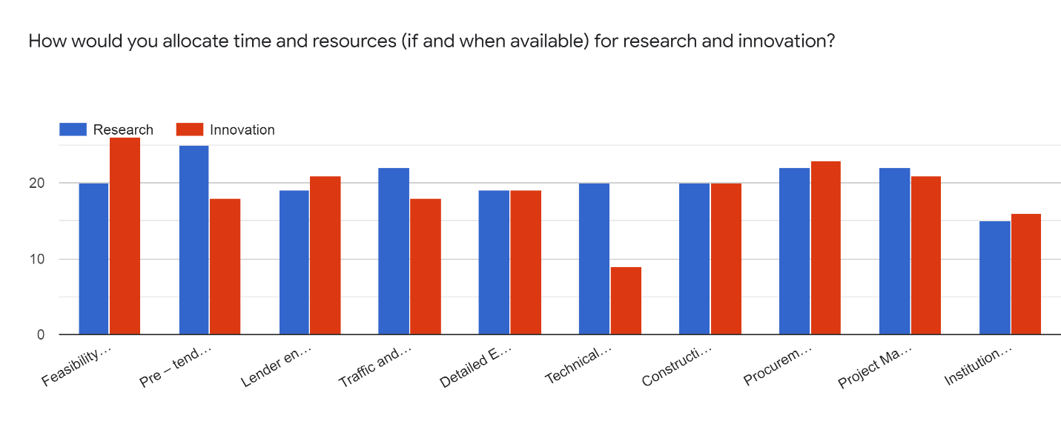

**4.** **Results & Recommendations**

**4.1 Findings and conclusions from the research**

When respondents were asked about how frequently an area of highway consultancy should be researched the average score that we got from the responses indicates that there should be an average focus given to the research meaning that it must be a point of focus when we are considering a yearly plan for our consulting firm. Thus, indicating that research is important and vital for a highway consulting firm.

When respondents were asked about how frequently innovations should be taking place the response was again an average focus. Thus, again we can conclude that while we are preparing a yearly plan for our highway consulting firm innovation too should be a point of focus. So, we come to an interesting conclusion that is that innovations are as important as research from the viewpoint of respondents all of whom are civil engineers.

Now when the respondents were asked about the timing of innovation that highway consulting firms should be choosing to launch its innovation most of the respondents (47.4%) believed the timing should be as per the convenience of the firm and should be completely independent of the timing of other firms. 1/4 of the respondents felt that it should be done when competitors do it while the remaining 1/4 held the view that it should be done at specific time intervals. Thus, we can conclude that innovation is an advantage, and it must be used to one’s advantage.

When respondents were asked what they thought about how long does an innovation last in the minds of the consumers. Most of the respondents thought that it would last for about five years and if we take an average of all the responses it comes out to be close to five years (4.31 years). Through this we can understand that an innovation has a lasting impact on the consumer’s mindset. After getting this information we can genuinely appreciate the importance of innovation as far as highway consulting is concerned.

Now, with regards to the type of innovation that is most suitable for highway consultancy, most of the respondents that is 36.8% think that a disruptive innovation would be the most suitable one. then about 31.6% people in the response group think that architectural innovation would be the most suitable while 23.7% respondents think that an incremental innovation would do the trick. Only 7% people think that a radical innovation is needed for highway consultancy. So, we can understand that it would be either a disruptive innovation or an architectural innovation that would be ideally suited for the field of highway consultancy.

When the respondents were asked to numerically rate the area of highway consultancy versus the need for Research. They gave high scores to traffic and road safety services, Detailed engineering design and procurement assistance and project management. whereas the other six areas received a below average score. does we can conclude that our research should consider traffic design procurement and project management first and then if the resources are left, we can consider other areas like feasibility studies, pre tendering services, lending services etc.

When the respondents were asked to numerically rate the area of highway consultancy versus need for most immediate innovation. They gave high scores too feasibility studies, pre tendering services, Detailed engineering design and project management. While the other six I received low scores. So, if we want to get an estimate of what area needs innovation, we can refer to this data.

Now further about 30% respondents feel that research and innovation are related while 36.8% respondents feel that they are not at all related. There is also a third group which makes up 34.2% and these people think that research and innovation are themselves dependent on a third factor of the business environment.

Further when we asked the respondents as to what strategic option would be most suitable for funding the research and innovations in highway consultancy then 36.8% respondents felt that it should be done with the earned income, 28.9% thought that investment should be used, while 21.1% chose to rely on borrowings for financing, 13.2% felt that investors could help.

Now lastly, we asked the respondents about allocating time and resources for research and innovation if they were to choose one for every area in highway consultancy. Almost equal number of people were siding with either research or innovation thereby we can conclude that whether time and resources are allocated to research or when they are allocated to innovation it does not make a difference at least to the respondents.

Now after going through all this, we can conclude that research and innovation is something that a highway consultancy firm cannot let go off. However, they must invest their time, resources, and money to get things done. Out of these three the most important is funds or finance. So, in trying to devise a solution we must have a strategy to acquire and manage finances in the best way possible, and that is what will make the proposed solution.

**4.2 The proposed solution and recommendations**

Indian road network is the second largest in the world and it carries 87% of the passengers and about 60% of goods and services. India has a remarkably high highway density which equals US. But the quality standards safety standards and load bearing capacity of our roads it is a bit inferior. Improving our national highways is one of the most important agendas of our country and providers of infrastructure consulting services and other road development bodies and councils throughout India. now improving anything needs research and innovation and investing in these two. And as we have concluded earlier it is the funding part for research and innovation that is most crucial.

Currently highways would need about ₹4 trillion of investment on an annual basis and that is the main issue in this we will need the help of private players so that we can manage this huge amount of money. If we look at the history NHAI (National Highways Authority of India) entered a Build Operate Transfer model PPP (Public Private Partnership) it witnessed a growth in the first decade and was quite successful initially. However, it could not hold on to the success and the funding model declined, after its decline NHAI thought of a new model called the Hybrid Annuity Model or HAM, under this model 2/5 of the total cost is paid for by the government.

Then another model known as toll operate transfer model has also been successful, but it does not provide enough financial support that is why there is a need for an alternative funding model.

We recommend that NHAI should be using multiple methods to obtain and fulfill its capital needs this is where infrastructure consulting firms come into play different methods need the help of different players in the market and infrastructure consulting firms can really cash in this opportunity by partnering with National Highway authority of India firstly for securing the amount obtained as revenue from tolls then it can also enter into partnership with the government so that they can obtain revenue from the increase in the property rates around newly improved roadways this can be a great opportunity to reduce some financial burden.

**5.** **Key Learnings, Challenges & Follow-up**

**5.1 Key learnings from this research**

There have been many learnings from this research work. The first thing that was learned is that there have been much more innovations in the past decade and that innovations are becoming a norm for the consultancy firms to remain relevant. Also, that it is better to do research adequately than to rely on doing a lot of hefty research all at once. We also learned that the new research is trying to understand the complexity of research work in highway engineering and trying to make the services provided accessible to every stratum of the society irrespective of the economy and funds available. We also see a bend of mind towards sustainable and environment friendly research and innovation. Infrastructure consulting firms are looking towards disruptive innovation measures to sustain and remain relevant.

**5.2 Limitations of this research**

This is a descriptive research therefore it seeks to find only what where and when of highway consultancy. We have found the answers to questions like when should research and innovation be taking place how often they should be taking place what areas they should be taking place in along with the scale on which it should be done. Fund allocation has also been discussed. what type of innovation should be taking place and what strategic option should be used to fund our innovation and research projects. What it does not discuss is why should a particular research be done or how would an innovation come into being or why was that innovation preferred over all other alternatives that might have existed.

**5.3 Directions for further research**

Anyone who wants to take up this research further should be very thorough with the use of artificial intelligence and machine learning for better management and maintenance of the road networks and should be curious enough to try and understand the environmental implications over an extended period after a particular research or innovation is implemented.

**References:**

1. LEA Group, Our Operating Companies

https://www.lea.ca/About-LEA/Operating-Companies

1. Rogers, Martin (2002). Highway engineering. Oxford, UK: Blackwell Science. ISBN 978-0-632-05993-5.
2. O'Flaherty, edited by C.A. (2002). Highways the location, design, construction, and maintenance of road pavements (4th ed.). Oxford: Butterworth-Heinemann. ISBN 978-0-7506-5090-8.
3. "Highway engineering." McGraw-Hill Concise Encyclopedia of Science and Technology. New York: McGraw-Hill, 2006. Credo Reference. Web. 13 February 2013.
4. Chin, Antony T.H. "Financing Highways." The Handbook of Highway Engineering. Ed. T.W. Fwa. CRC Press, 2005.
5. Estache, A., Romero, M., and Strong, J. 2000. The Long and Winding Path to Private Financing and Regulation of Toll Roads. The World Bank, Washington, DC, 49 pp.
6. Aziz, M.A. "Environmental Impact Assessment of Highway Development." The Handbook of Highway Engineering. Ed. T.W. Fwa. CRC Press, 2005.
7. World Health Organization, 2004. World Report on Road Traffic Injury Prevention. World Health Organization, Geneva.
8. Johnston, Ian. "Highway Safety." The Handbook of Highway Engineering. Ed. T.W. Fwa. CRC Press, 2005.
9. Cheu, R.L. "Highway Geometric Design." The Handbook of Highway Engineering. Ed. T.W. Fwa. CRC Press, 2005.
10. Tam, Weng On. "Highway Materials." The Handbook of Highway Engineering. Ed. T.W. Fwa. CRC Press, 2005.
11. Mamlouk, Michael S. "Design of Flexible Pavements." The Handbook of Highway Engineering. Ed. T.W. Fwa. CRC Press, 2005.
12. Fwa, T.F. and Wei, Liu. "Design of Rigid Pavements." The Handbook of Highway Engineering. Ed. T.W. Fwa. CRC Press, 2005.
13. Tia, Mang. "Overlay Design for Flexible Pavements." The Handbook of Highway Engineering. Ed. T.W. Fwa. CRC Press, 2005.
14. Fwa, T.F. "Overlay Design for Rigid Pavements." The Handbook of Highway Engineering. Ed. T.W. Fwa. CRC Press, 2005.
15. Gunalan, K.N. "Highway Construction." The Handbook of Highway Engineering. Ed. T.W. Fwa. CRC Press, 2005.
16. "AggreBind - Soil Stabilized Roads and Highways".
17. Sirvio, Konsta (2017) Advances in predictive maintenance planning of roads by empirical models. Aalto University publication series DOCTORAL DISSERTATIONS, 166/2017. (https://www.researchgate.net/publication/319998419_Advances_in_predictive_maintenance_planning_of_roads_by_empirical_models)
18. Van Wijk, Ian. "Highway Maintenance." The Handbook of Highway Engineering. Ed. T.W. Fwa. CRC Press, 2005.
19. Highway Innovation

WE MAKE IT REAL https://highwayinnovation.com/

1. FERROVIAL INNOVATION Innovation in Highways https://www.ferrovial.com/en/innovation/innovation-in-highways/
2. Civil Engineering Research : Highways and Transportation

https://www.birmingham.ac.uk/research/activity/civil-engineering/highways-transport/index.aspx

1. Highway construction: Innovation is the name of the game

September 30, 2019 1:04 AM

By Elias George

https://www.financialexpress.com/infrastructure/highway-construction-innovation-is-the-name-of-the-game/1721358/